Emergency Response Plan – Harrow Bay Offshore Construction
Bridging ERP for Weyland and marine contractors
Hannah Weber · 12 June 2026 · HB-HSE-ERP-0001

1. Scope
This plan applies to all offshore construction activities of Harrow Bay Offshore Wind (UK North Sea, 38 km off the coast of Harrow Bay) and to the marine coordination centre at the Port of Eastholm. It bridges Weyland's emergency arrangements with those of the vessel operators (e.g. Atlas Marine Contractors for MV Sea Atlas). Vessel masters remain in command of emergencies on their vessels.

2. Emergency organisation
Role | Who | Responsibility
On-scene commander | Vessel master | Command on the vessel, first response, communication with the Coastguard
Marine coordinator (24/7) | Ingrid Solberg's team, Port of Eastholm | Single point of contact, vessel traffic, alerts the duty manager
Duty manager (on call) | Felix Brandt / rota | Leads Weyland's emergency response team, decisions on resources
HSE on call | Yusuf Demir / Hannah Weber | HSE advice, regulator notification, investigation
Crisis management team | Elena Márquez, CEO, Communications | Escalated events: fatality, major pollution, media

3. Scenarios and first actions
Scenario | First actions
Person overboard | Raise alarm, throw lifebuoy, PLB alert, launch MOB boat, Mayday via VHF 16, all vessels in field to assist
Serious injury / illness | Offshore medic, telemedical advice, medevac by Coastguard helicopter or fast CTV to Eastholm
Rescue from height (TP, monopile, crane) | Vessel rescue team with rescue kit, max. 15 min to casualty, lower to deck
Confined space rescue (monopile interior) | Standby person, rescue tripod, breathing apparatus team from vessel
Fire on vessel | Vessel fire plan, muster, inform marine coordinator
Collision / allision | Muster, damage assessment, inform Coastguard, notice to mariners
Dropped object | All-stop, first aid, barrier area, flash report within 24 h (see HSE-INC-2026-018)
Oil spill | SOPEP, contain on deck, inform marine regulator and Clara Neumann
UXO found | Stop work, 1,000 m exclusion for vessels, inform Coastguard and UXO specialist
Severe weather | Weather limits per activity, seek shelter or jack up, crew transfer suspended

4. Communication
- Emergency: VHF channel 16; field working channel 72.
- Marine coordination centre: +44 1632 960 410 (24/7).
- Duty manager mobile: +44 7700 900 512.
- All persons offshore carry a personal locator beacon (AIS MOB) and are tracked in the marine coordination system.

5. Drills
Drill | Frequency | Last held
Person overboard (each vessel) | Monthly | 2026-09-16
Medevac exercise with Coastguard | Annually | 2026-05-27
Rescue from height | Quarterly | 2026-08-05
Crisis management desktop exercise | Annually | 2026-03-18

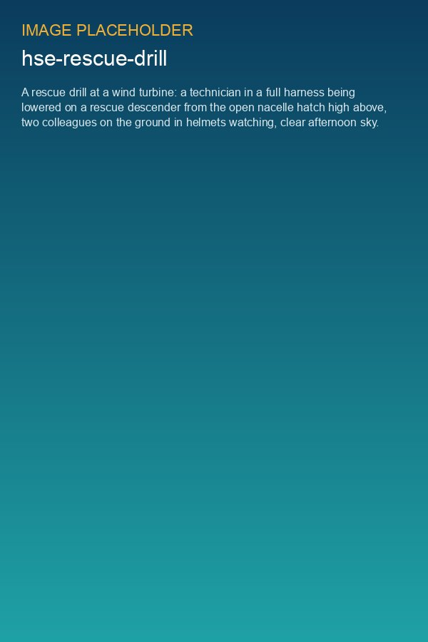
Rescue from height drill

